Infosys SpringBoard Internship Documentation
Project Plan: QueryTube:AI_SemanticSearchTube

Milestone 1: YouTube Data Collection and API Mastery (Weeks 1–2)
• Module 1: YouTube API Fundamentals and Video Metadata Extraction
◦ Set up a Google Cloud project and generate an API key.
◦ Choose a YouTube channel (with 100–350 diverse videos).
◦ Learn how to use the YouTube Search endpoint (https://www.googleapis.com/youtube/v3/search).
◦ Extract all videos from the selected channel using pagination logic.
◦ Create a custom function to extract video ID, published date, and title.
◦ Learning Outcome: Understand the YouTube Data API v3 and authenticate using an API key.
• Module 2: Exploratory Data Analysis (EDA) and Structuring Video Metadata
◦ Store extracted data in a Polars or Pandas dataframe.
◦ Analyze data for row/column uniqueness, title distributions, and publish frequency.
◦ Perform EDA on metadata, including date distribution and missing values.
◦ Deliverable: A cleaned video metadata dataset.
Milestone 2: Transcript Extraction and Data Cleaning (Weeks 3–4)
• Module 3: Extracting Video Transcripts with YouTube Transcript API
◦ Use the youtube_transcript_api Python package to fetch auto-generate d captions or transcripts.
◦ Collect and organize transcript text.
◦ Identify and log videos without available transcripts.
◦ Deliverable: A dataframe enriched with a transcript column.
• Module 4: Cleaning and Normalizing Transcripts / Evaluation Setup
◦ Standardize titles and transcripts by removing or replacing special characters.
◦ Handle null or missing transcript entries.
◦ Generate an initial list of ~70–80 search queries (topics, keywords, or phrases) relevant to the videos and map them.
◦ Familiarize with at least three SentenceTransformer models (e.g., all-MiniLM-L6-v2).
◦ Prepare the evaluation setup to compare semantic similarity performance.
◦ Deliverable: Cleaned dataset with video_id, title, datetime, and transcript.
Milestone 3: Sentence Transformer Evaluation for Semantic Search (Week 5-6)
• Module 5: Cleaning and Normalizing Transcripts (Evaluation Phase)
◦ Use SentenceTransformer to embed video titles and transcripts using three candidate models.
◦ Embed the pre-defined 70–80 search queries.
◦ Compare distance-based (euclidean, manhattan, chebyshev) and similarity-based (cosine similarity, dot product) ranking methods.
◦ Evaluate similarity between queries and video transcripts/titles to see how well each model ranks the correct video.
◦ Deliverable: An evaluation summary that identifies the best-performing model and method for semantic retrieval.
• Module 6: Building a Video Index Using Embeddings
◦ Choose the best SentenceTransformer model identified in Week 5.
◦ Embed the titles and transcripts of each video.
◦ Concatenate and append these embeddings (e.g., ~768+ embedding features per video) to the original dataset.
◦ Save the final dataframe (the complete video index) using Polars or pandas (Parquet or CSV file).
Milestone 4: Implementing and Tuning Semantic Search and creating a final search function (Week 7-8)
• Module 7: Optimizing Result Quality
◦ Load the video index and selected transformer model.
◦ Encode the incoming user query.
◦ Use distance metrics (e.g., manhattan, euclidean, cosine) to compute similarity between the query embedding and stored vectors.
◦ Rank the closest matches using title and transcript embeddings jointly.
◦ Understand and tune thresholds and top_k rankings to optimize result quality.
◦ Deliverable: A working search function named returnSearchResults(query, df).
• Module 8: Final Deployment & Search Interface
◦ Use the optimized model and distance metric pair.
◦ Create a Python script that loads the index, runs the query search, and returns top-5 matches.
◦ Build an interactive Gradio interface that accepts a query and displays the top-5 embedded YouTube videos.
◦ Prepare summary presentation and code documentation.
◦ Final Deliverable: The final query-to-top-5 search engine function and the deployed Gradio interface

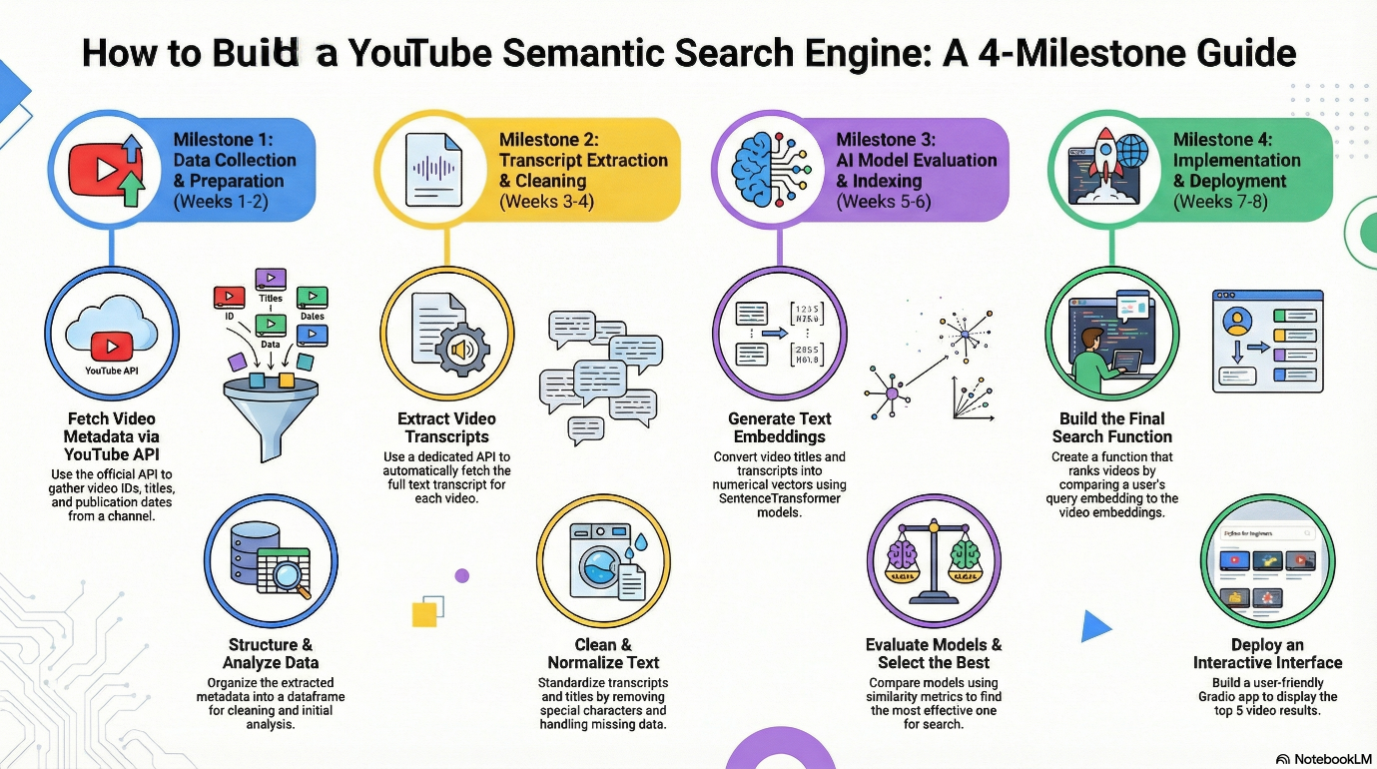
Project Overview:-
This project is essentially about building your own YouTube Semantic Search Engine, similar to:
- Google Search for YouTube videos
- ChatGPT search but for YouTube content
- A mini version of YouTube Search powered by Transformers
Users will type natural language queries like:
- “How to learn data science step-by-step?”
- “Best tutorials for CNN”
- “Yoga for beginners with knee pain”
And your system should find the 5 most relevant videos based on:
- Video title
- Transcript
- Semantic meaning using embeddings
Not keyword match → semantic understanding.

Overview of the Process and Key Outcomes
The project involves gaining hands-on experience in NLP (Natural Language Processing), data engineering, and information retrieval by constructing a complete semantic search engine.
The successful completion of the project is expected to yield the following key outcomes:
• Extraction and Preprocessing: Extracting and preprocessing metadata and transcripts from YouTube videos using APIs.
• Model Application: Understanding and applying transformer-based text embedding models.
• Evaluation: Evaluating similarity and distance metrics for effective semantic retrieval.
• Deployment: Building and deploying a complete semantic video search pipeline.
The conceptual workflow illustrates this process, starting with the Youtube API for extraction, leading to the creation of a Youtube data dataset and a Query dataset. This data is used in conjunction with the selection of 3 sentence transformers for Sentence Transformer Evaluation for Semantic Search. The best results inform the Building a Video Index Using Embeddings, which ultimately leads to creating a final search function.

On Day1 :-
- I understand the process of project bulding from starting to ending
I learned what is semantic search
- I also understand that we can improve our project into 2025 version by doing the major chances Of replacing the databases and chunking systems
- I also learned how to extract the details of youtube data using youtube api, how to get the youtube api key from the google cloud
